Lab

SVN with TortoiseSVN and Project Hosting on Google Code

Table of content

1 Installation 2
2 Configure TortoiseSVN 4
2.1 Upload Project 4
2.2 Get the project from server 11
2.3 Revert source 15
2.4 Upload Edited Source 18
2.5 Update Project Source 20
3 Deploy SVN server use Project Hosting on Google Code 21

Installation

Open Tortoise Install file. Click Next
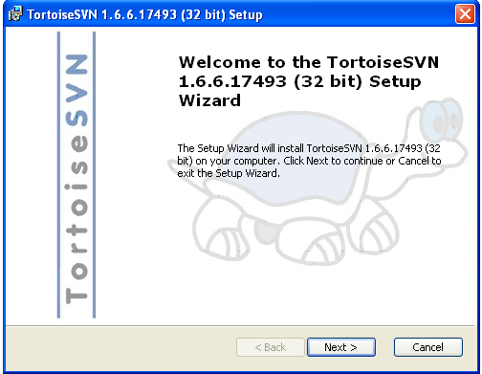

Check Accept the term.... Click next.

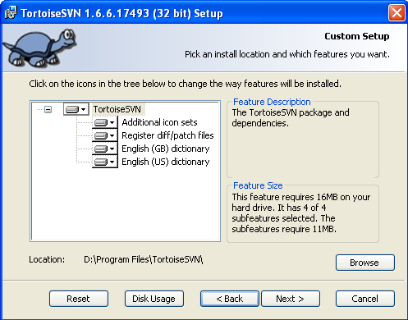

Click Install and Finish.
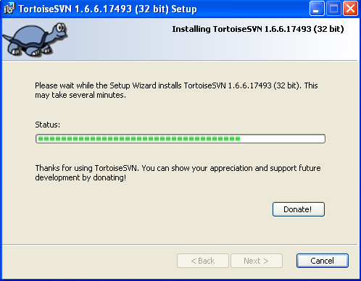

Restart the computer.
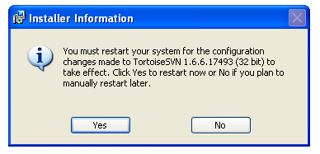

Configure TortoiseSVN

Upload Project

Click right mouse in explorer. Choose Repo-browser.

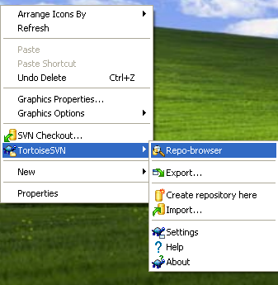

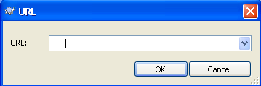

Using Google code to support Tortoise SVN

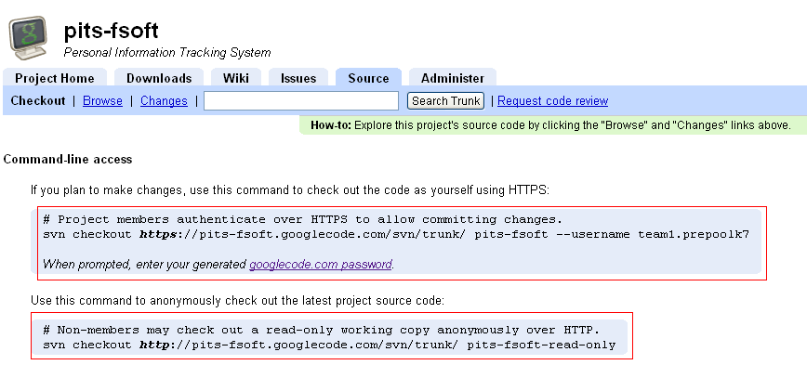

URL is available on website

Get the Password by click the hyperlink google.com.password

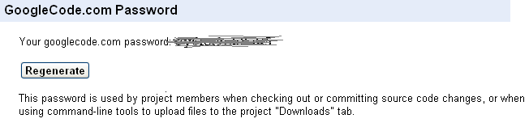

Get the URL one the website and insert to URL textbox. Click OK
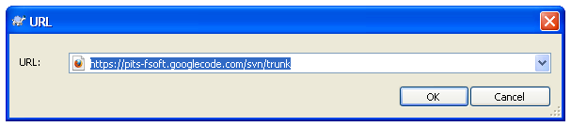

Insert Username and Password. Click OK
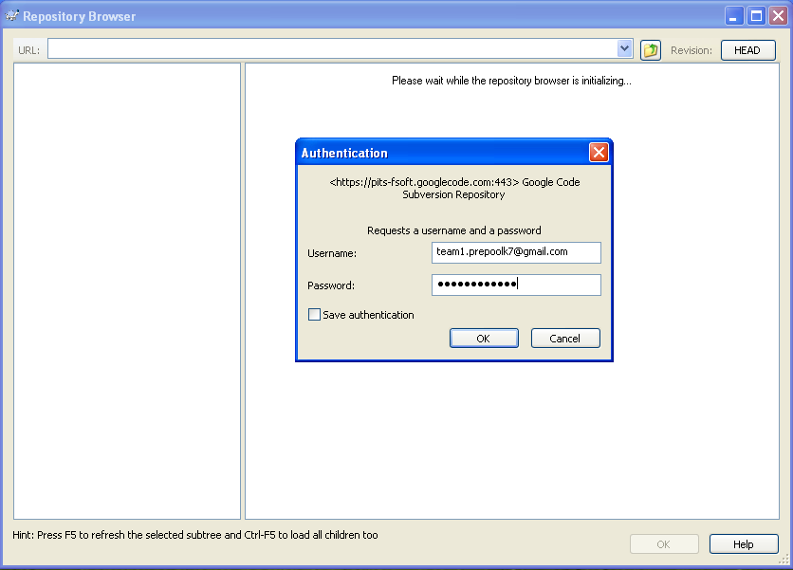

The result screen is below.
Click right mouse click to folder trunk, click Add folder

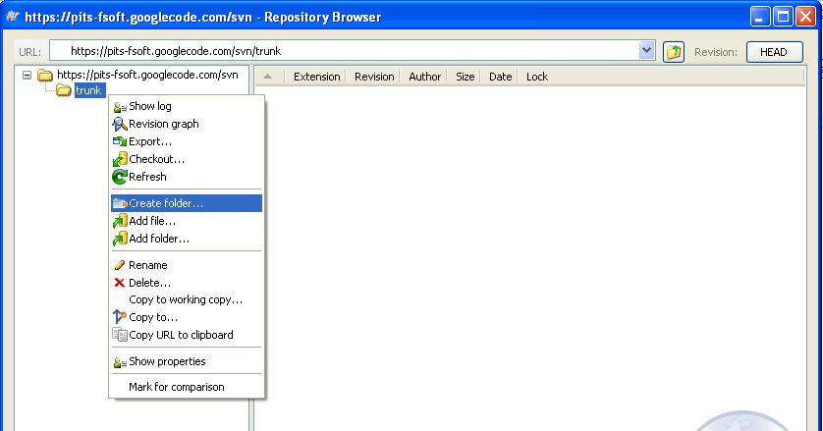

Insert name of project. Click OK;
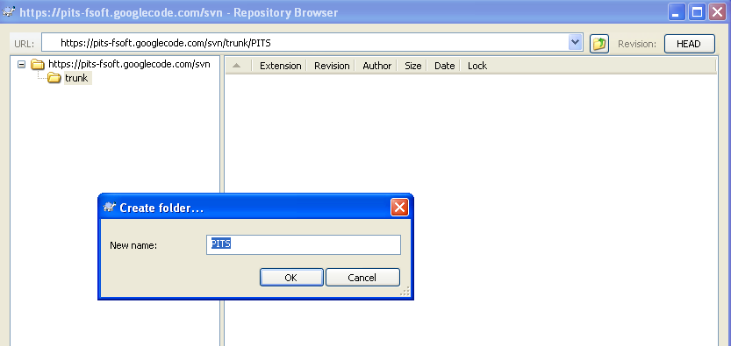

Click Ok
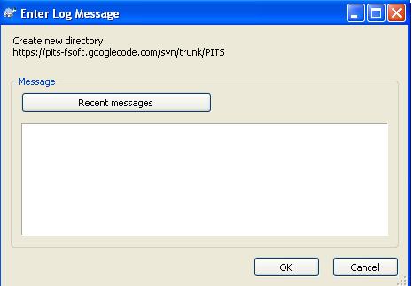

Click right mouse click from project folder
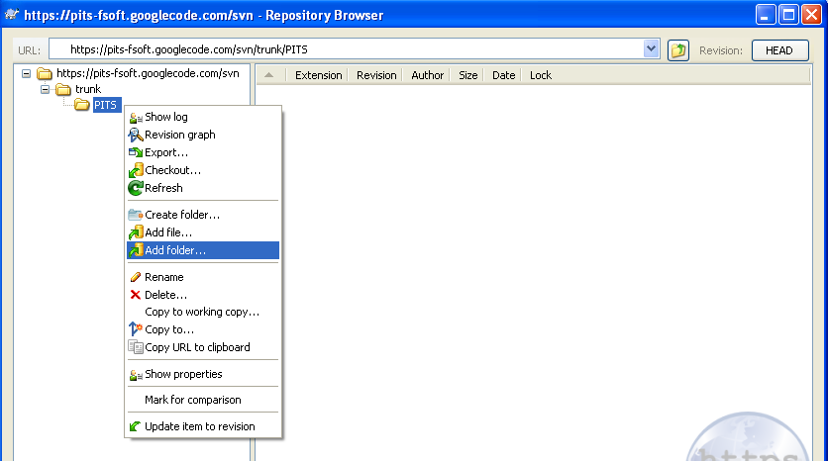

Browse the Project folder in your computer. Click OK
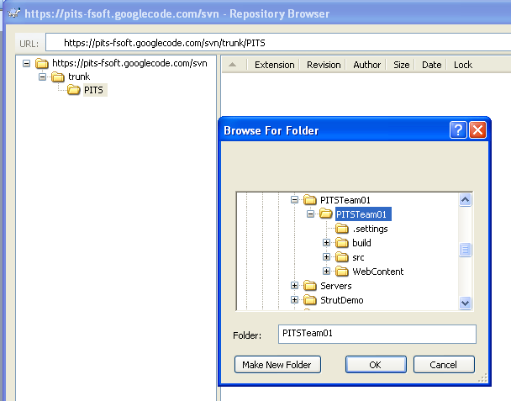

Click OK to import
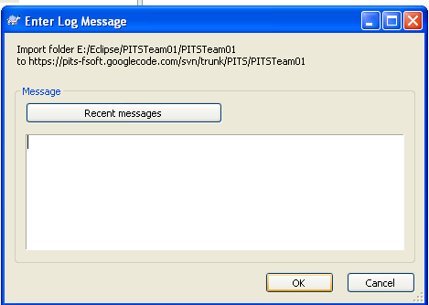

Waiting for uploading project to server
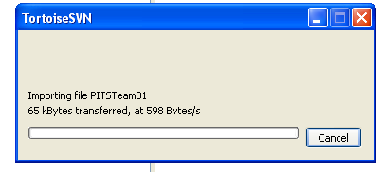

The result is displayed as the below screen:
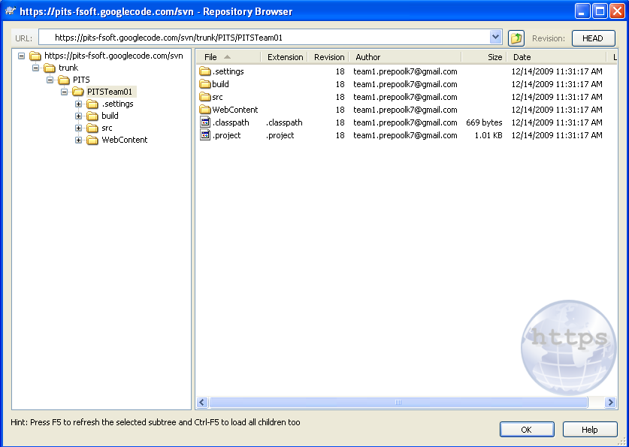

Get the project from server

In the Windows Explorer, Click right mouse click, choose SVN Checkout...
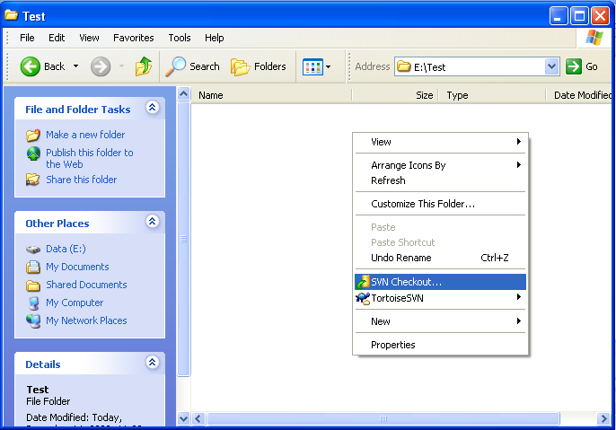

If you can’t remember URL Click button to browse
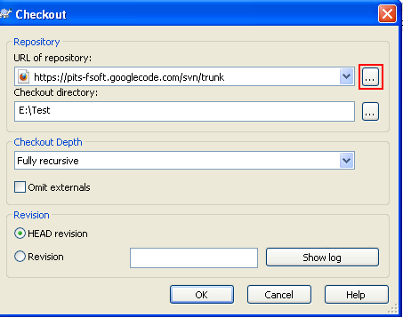

Input Username and password. Click OK

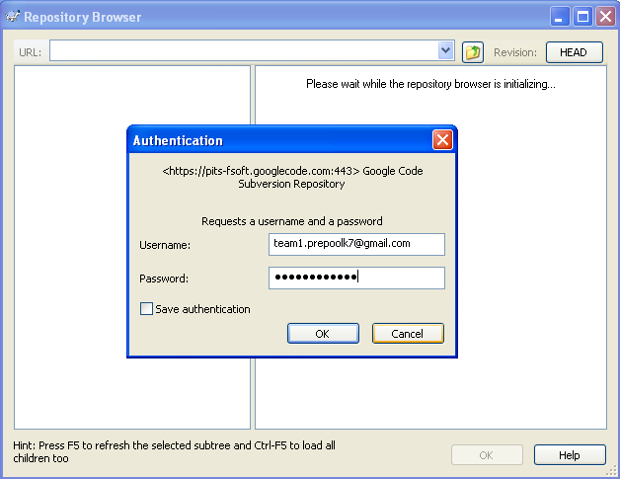

Select Project name. Then click the Ok button.
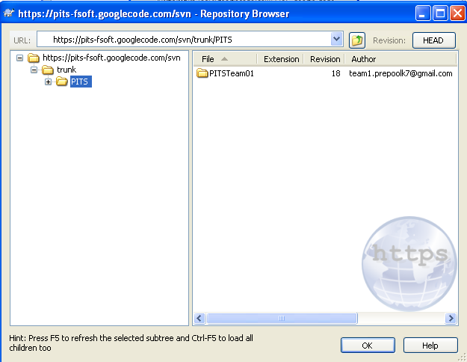

Click Ok to perform.
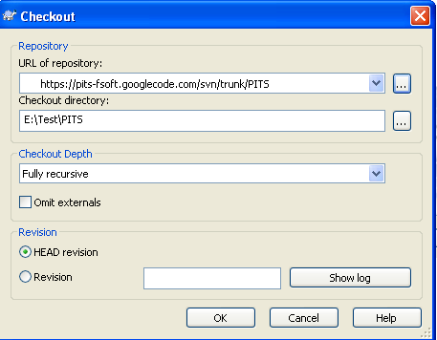

Waiting for download complete
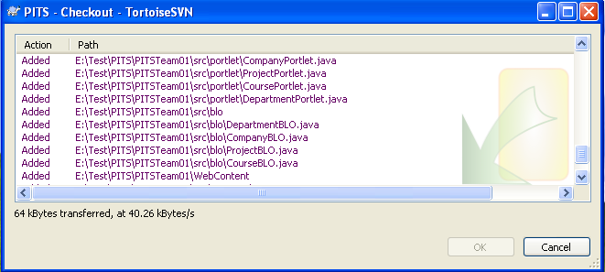
Click OK when transfer complete.

The result in the screen below


Revert source

If you change file, the red warning icon will show below:
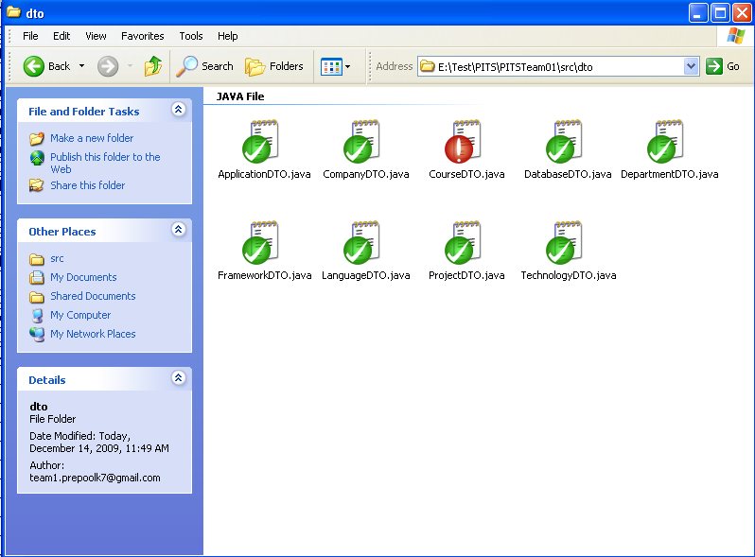

To previous version
Right-click on changed file, choose TortoiseSVN -> Click Revert...

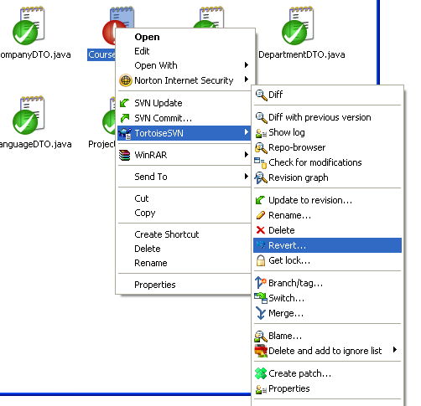

Choose file and click OK

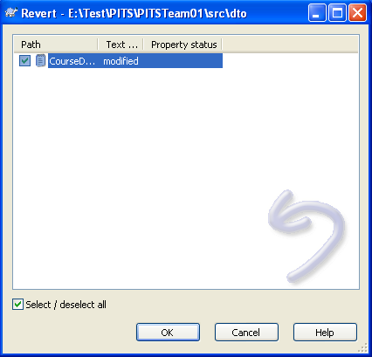

Click OK to complete Revert file
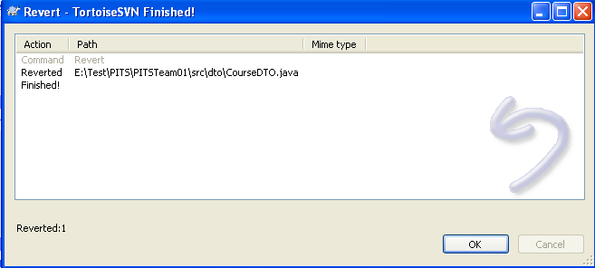

The result in the screen below
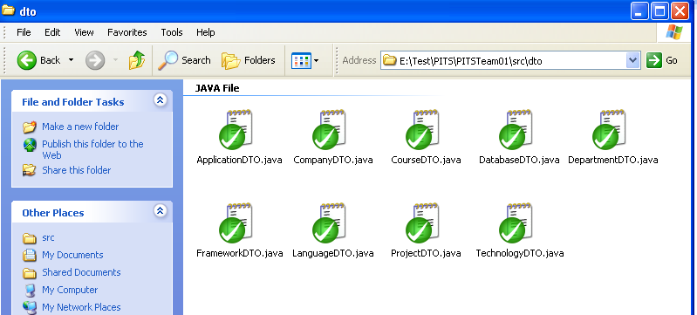

Upload Edited Source

Click right mouse click. Click SVN Commit...
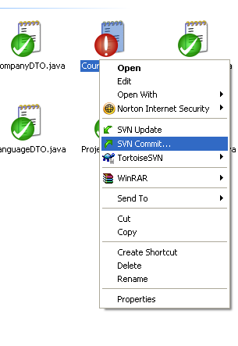

Click Ok to commit
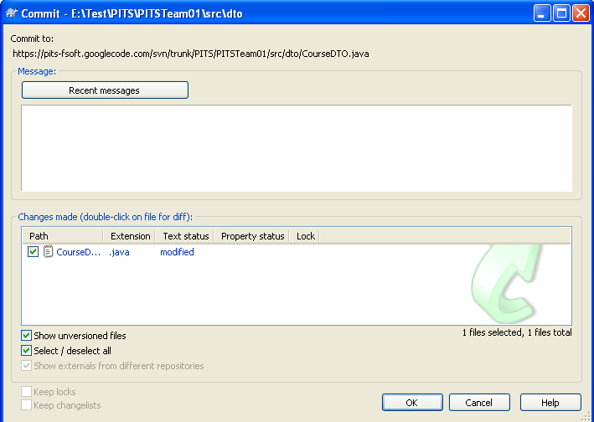

Click OK to complete

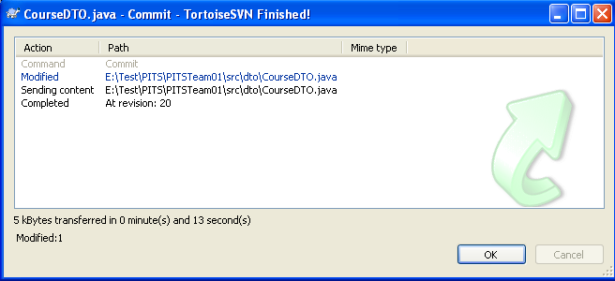

The result in the screen below

Update Project Source

In Windows Explorer, click right mouse click to Project folder. Choose SVN Update...
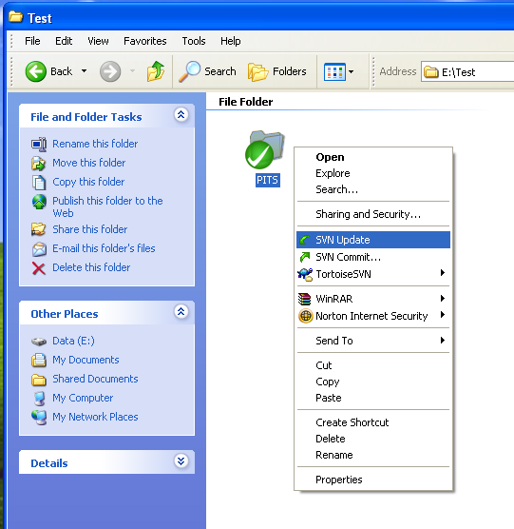
Waiting for update completing and click OK

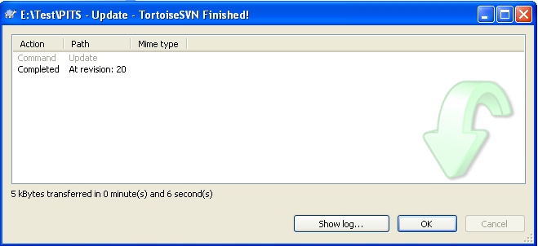

Deploy SVN server use Project Hosting on Google Code

Start Web Browse. Go to http://code.google.com/hosting/

Click on link “Create a new project”. Then Login with your Google Email Account

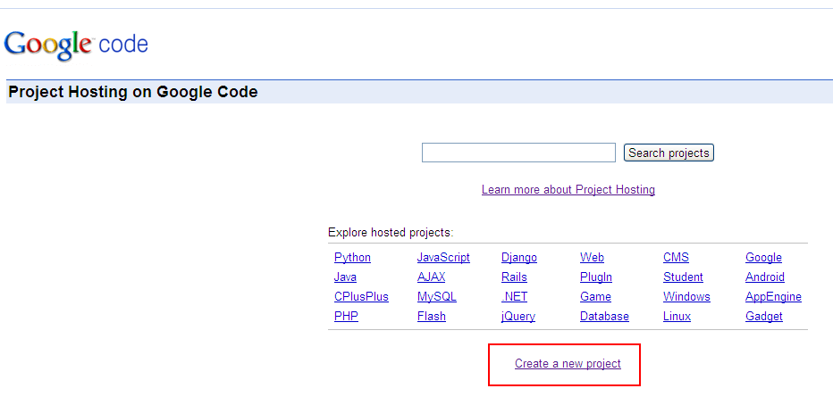
Input project information, version control system, and source code license. Click Create Project
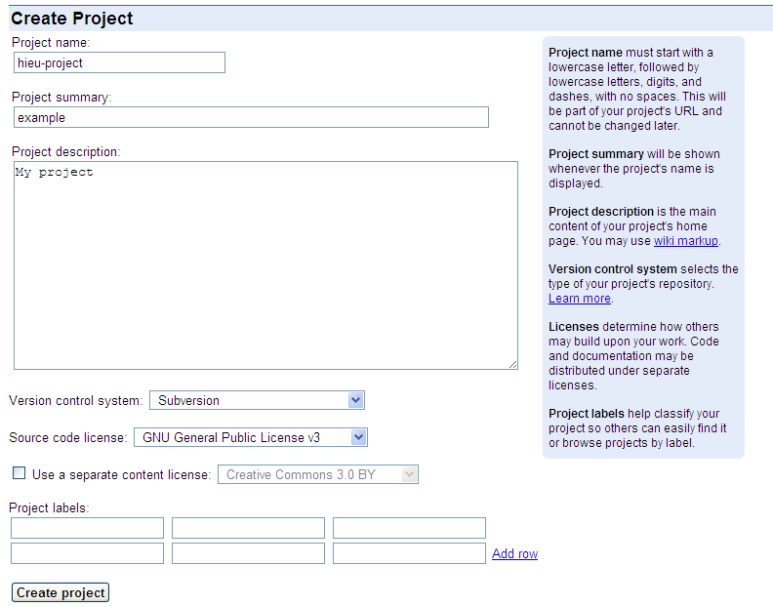

The result: your project URL looks like http://code.google.com/p/hieu-project/

Click to Source

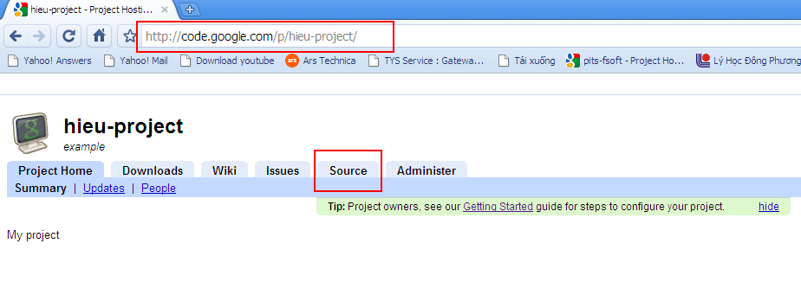

Your SVN URL looks like

https://hieu-project.googlecode.com/svn/trunk/

Click on link “googlecode.com.password” to get your password
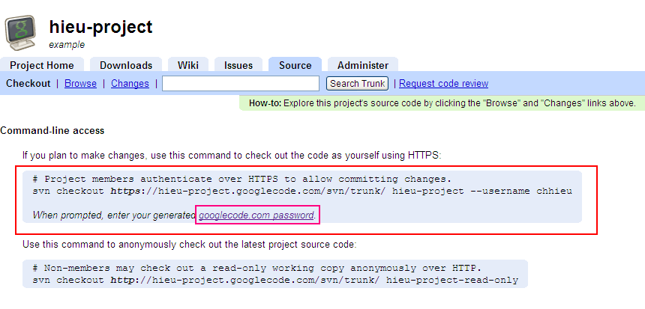

You need remember your GoogleCode password. You can change your password by click on Regenerate

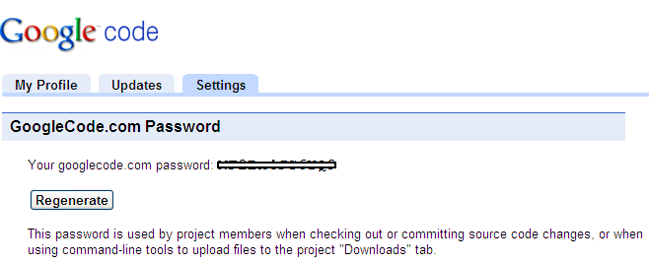

Back to your project site by click on Administer
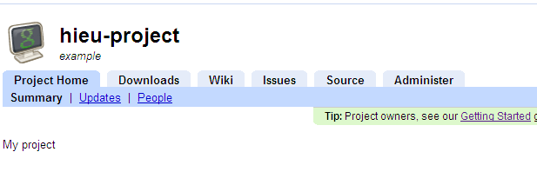

Click Project Member to set member role.

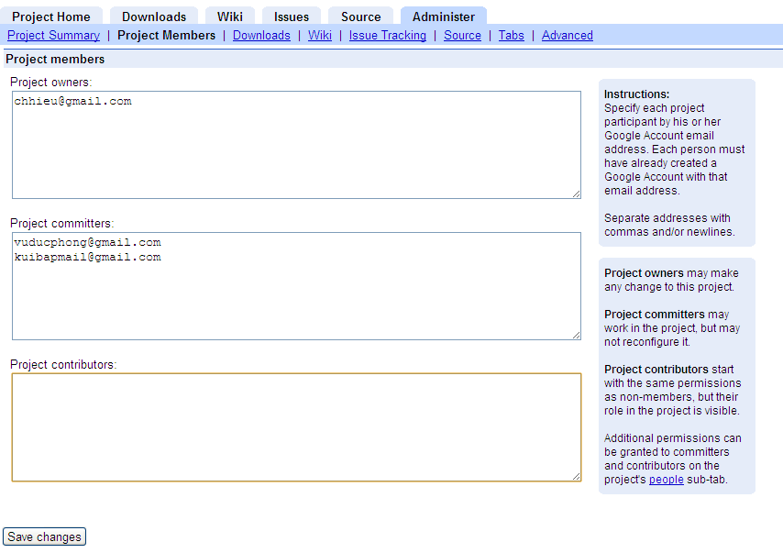

Project owners may make any change to this project.
Project committers may work in the project, but may not reconfigure it.
Project contributors start with the same permissions as non-members, but their role in the project is visible.

Project Members need get his/her GoogleCode.com password at
https://code.google.com/hosting/settings. You can change your password by click on Regenerate

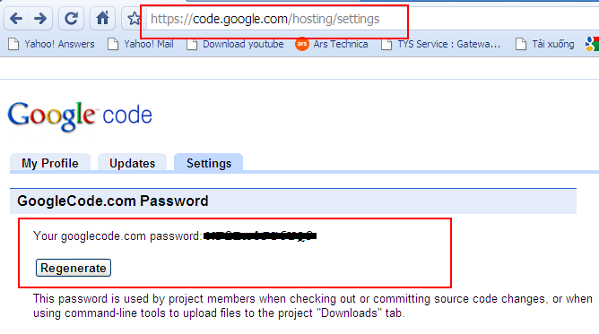

Back to Step 2.1 Upload Project

You can use the Google project hosting now!

